- When clicking on the banner on the library search page to sign in:

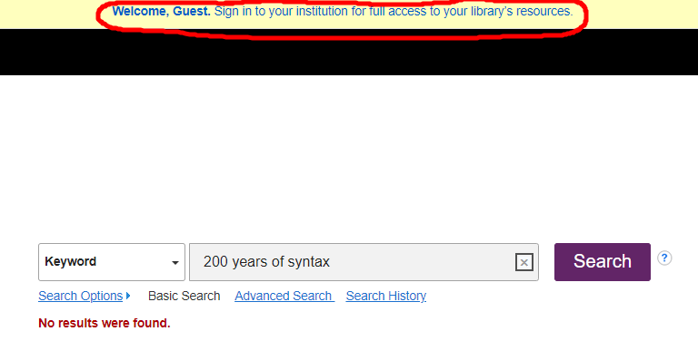

- It will take you to this EBSCO page:

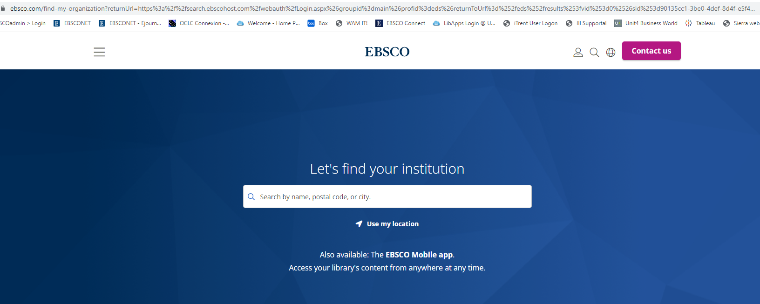

- Type in University of Essex in the search box and hit enter.

- Click on the result:

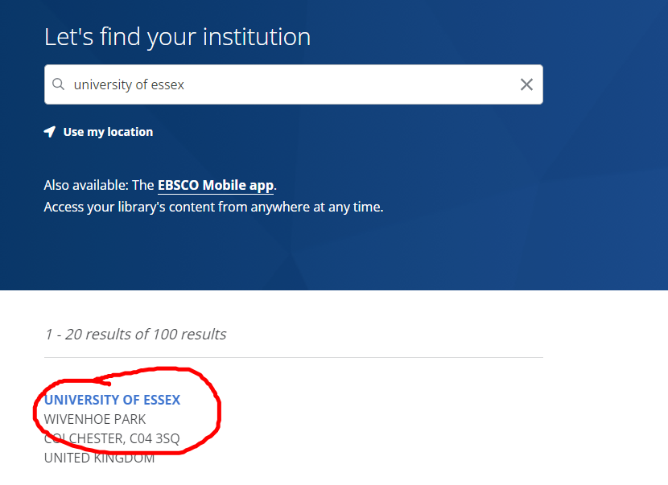

- You should then be taken to this sign-in page:

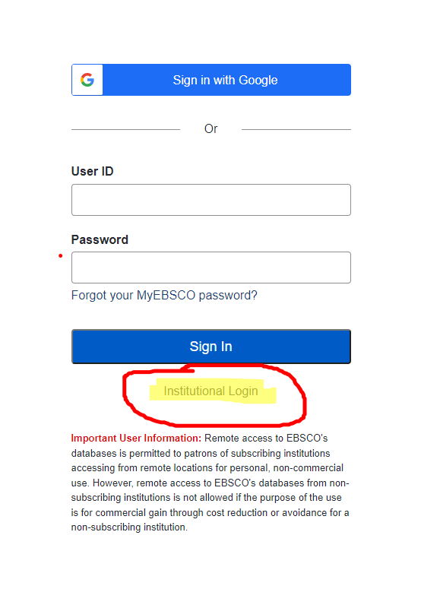

- Click on the “Institutional login” link underneath the Sign in button.

- This should then either log you in automatically (if you’ve already signed in on your device) or take you to the Essex lego man login screen:

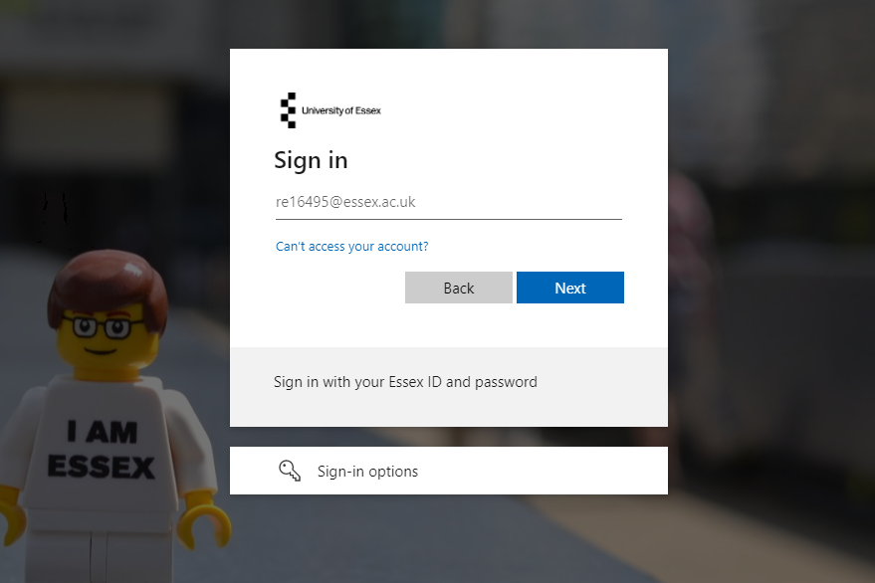

- On this page input your Essex login details.

